MARKER’S REPORT

Name of Marker : Munish Kumar

Course Code/Title : ANL201

Semester : Jan 2022

PART I

Overall Performance of Students in the Examination:

Briefly Describe:

Majority of students passed (class has 49 students). Of the 49 students, there were 44 submissions. Passing rate of 88% (statistics excludes non-submission). Of the 44 submissionsgraded, the only failure was due to an incomplete paper.
Shown below is the Mean grade of 67.27%.

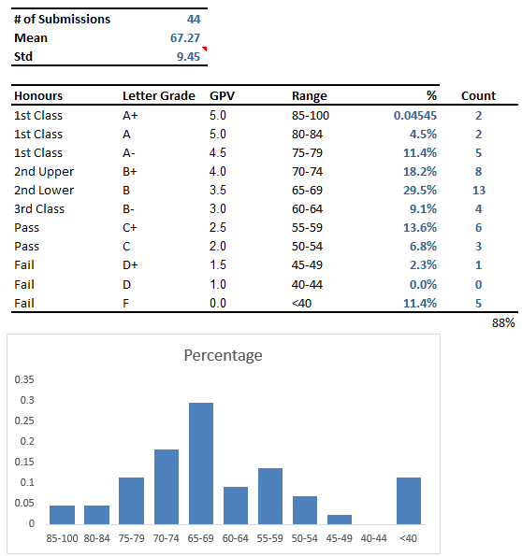

Range | 85-100 | 80-84 | 75-79 | 70-74 | 65-69 | 60-64 | 55-59 | 50-54 | 45-49 | 40-44 | <40
T04 | 2 | 2 | 5 | 8 | 13 | 4 | 6 | 3 | 1 | 0 | 5

Strengths and Weaknesses of Students in Examination:

Students can be broadly categorized into 2 groups. Students that understood the concept and were able to not only explain the theory but also use visualisation to support. The 2nd group of students understood the theory somewhat but lacked the creativity/ expertise to convert to suitable visualizations.
That said, all students submitted a Tableau workbook. The truly outstanding students understood that Tableau was a tool; the data analysis skills was the most important element. The poorer students tried to use visualisation as a crutch but because they were not able to verbalize what they said, created very confusing, often muddled interpretations.

PART II

Overall performance of Question 1a-1h

Briefly Describe:

S/N | Learning Outcomes | Bloom’s Level | Question Number | Mean Score | Pass Rate
1 | Describe an overview of business performance measurement strategy. | B2 | 1(a), 1(b) | 8.1 | 81.1
2 | Evaluate the appropriateness of business performance measures against  business strategy adopted | B6 | 1(c) | 4.3 | 71.6
3 | Discuss the design principles of performance reports and dashboards | B2 | 1(e) | 5.7 | 70.7
4 | Use appropriate visualization based on given data | B3 | 1(d), 1(g) | 23.1 | 68.0
5 | Summarise data through the use of business performance reports with the aid of data visualisation software | B2
6 | Develop business performance  dashboards using data visualisation software | B3 | 1(f), 1(h) | 13.6 | 61.8

Strengths and weaknesses of students with regard to Question 1a-1h, Tableau Workbook

Most students did reasonably well when it came to showing their skills with Tableau, refer to statistics below

 | 1a | 1b | 1c | 1d | 1e | 1f | 1g | 1h | Tab
Mean | 3.30 | 4.82 | 4.30 | 12.36 | 5.66 | 6.07 | 10.75 | 7.52 | 12.50
Standard  Error | 0.12 | 0.12 | 0.19 | 0.37 | 0.17 | 0.27 | 0.32 | 0.32 | 0.21
Median | 3.50 | 5.00 | 4.00 | 12.50 | 6.00 | 6.50 | 10.50 | 8.00 | 12.00
Mode | 4.00 | 5.00 | 4.00 | 13.00 | 5.00 | 7.00 | 10.00 | 9.00 | 12.00
Standard  Deviation | 0.79 | 0.81 | 1.27 | 2.48 | 1.10 | 1.82 | 2.11 | 2.12 | 1.37
Sample  Variance | 0.63 | 0.66 | 1.61 | 6.14 | 1.21 | 3.32 | 4.47 | 4.49 | 1.88
Kurtosis | - 1.15 | - 0.47 | 2.51 | - 0.39 | - 0.11 | 0.17 | 1.30 | 5.83 | - 0.25
Skewness | - 0.59 | - 0.19 | - 1.24 | - 0.27 | 0.07 | - 0.54 | - 0.71 | - 2.12 | 0.37
Range | 2.00 | 3.00 | 6.00 | 10.00 | 5.00 | 8.00 | 10.00 | 10.00 | 6.00
Minimum | 2.00 | 3.00 | - | 6.00 | 3.00 | 2.00 | 4.00 | - | 10.00
Maximum | 4.00 | 6.00 | 6.00 | 16.00 | 8.00 | 10.00 | 14.00 | 10.00 | 16.00
Sum | 145.00 | 212.00 | 189.00 | 544.00 | 249.00 | 267.00 | 473.00 | 331.00 | 550.00
Count | 44.00 | 44.00 | 44.00 | 44.00 | 44.00 | 44.00 | 44.00 | 44.00 | 44.00
Confidence  Level  (95.0%) | 0.24 | 0.25 | 0.39 | 0.75 | 0.33 | 0.55 | 0.64 | 0.64 | 0.42
Average | 82% | 80% | 72% | 69% | 71% | 61% | 67% | 63% | 63%

 |  | 24032022
Marker’s Signature |  | Date

